Working with Lists, Tuples, and Dictionaries Lab

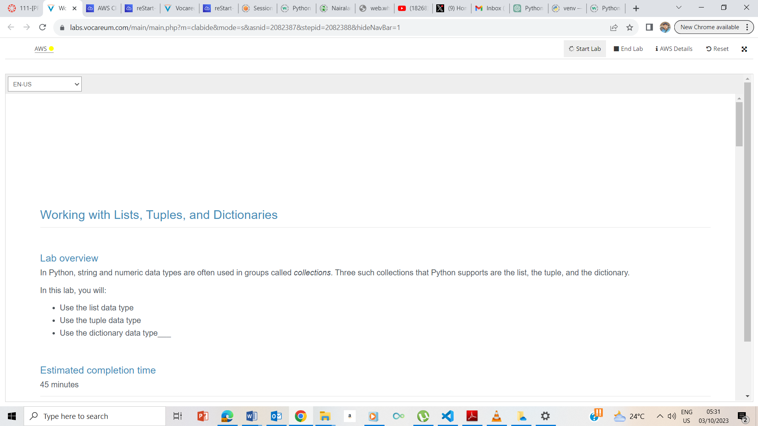

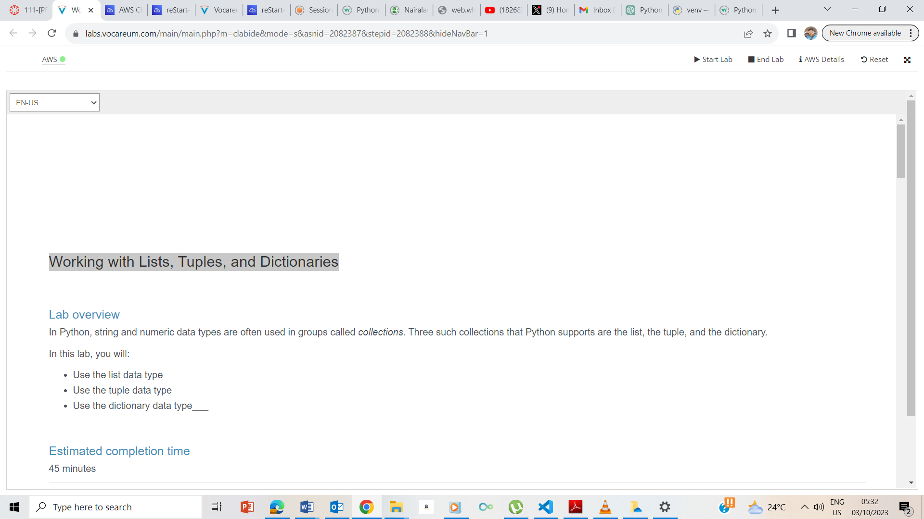

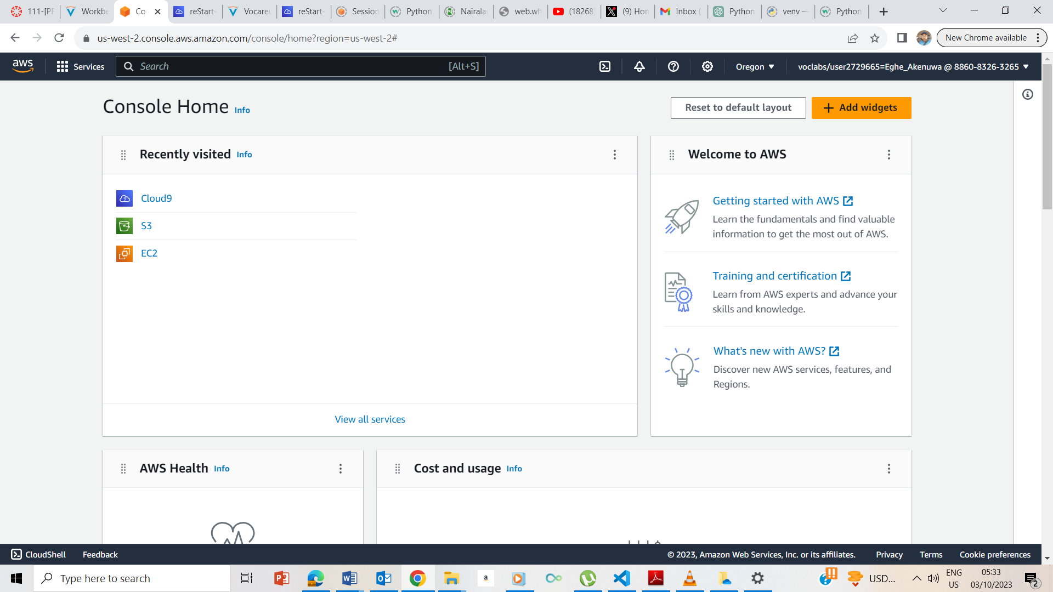

## **Creating your Python exercise file**

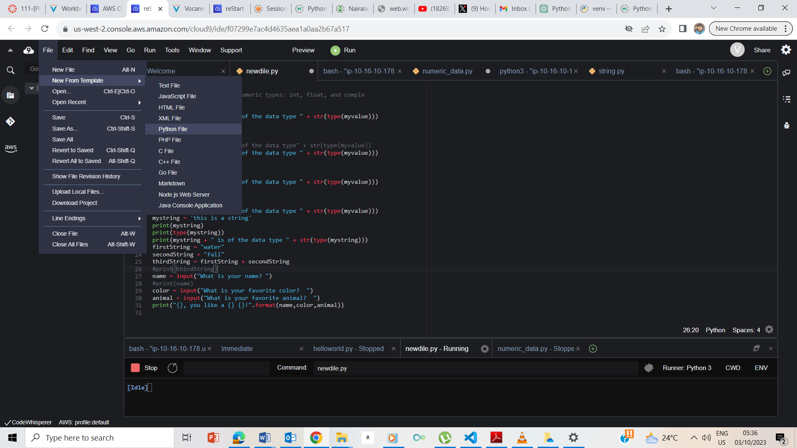

Clicked on File, then New From Template and then Python File and the saved the file

## **Accessing the terminal session**

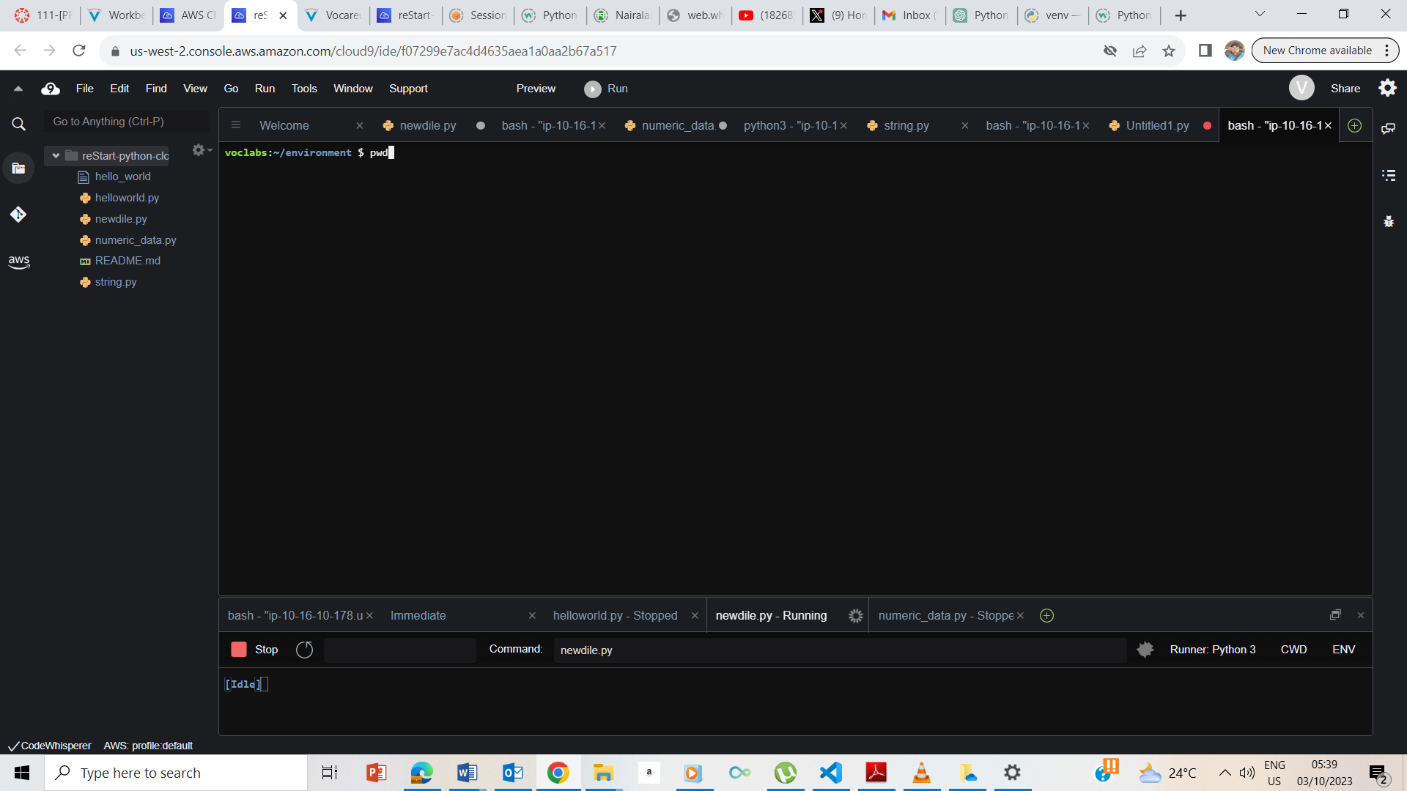

Clicked on New Terminal to open a new Terminal and I now typed pwd to take me to ec2-user/environment

### **Defining a list**

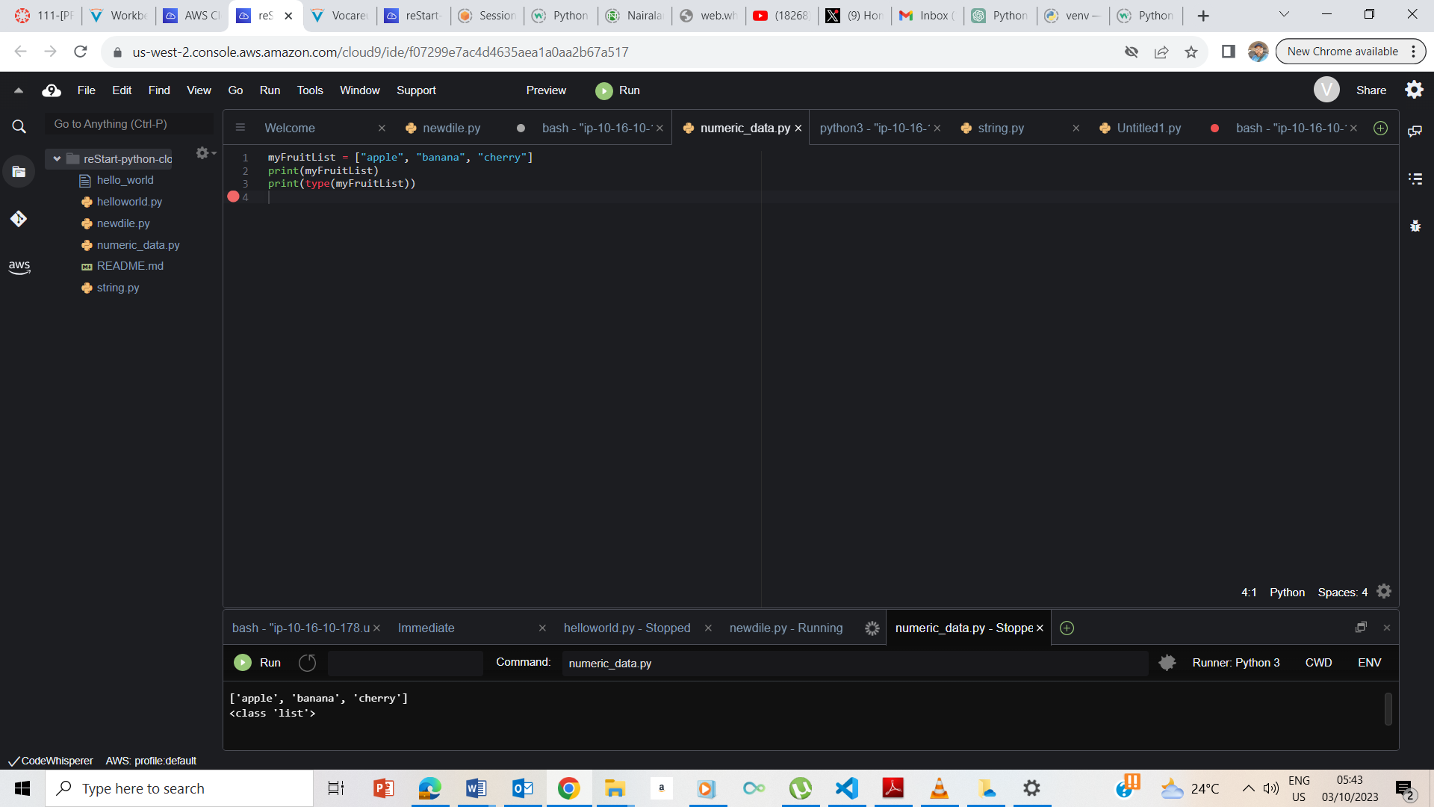Entered the instruction and the list of fruits is outputted and the type is shown as list

### **Accessing a list by position**

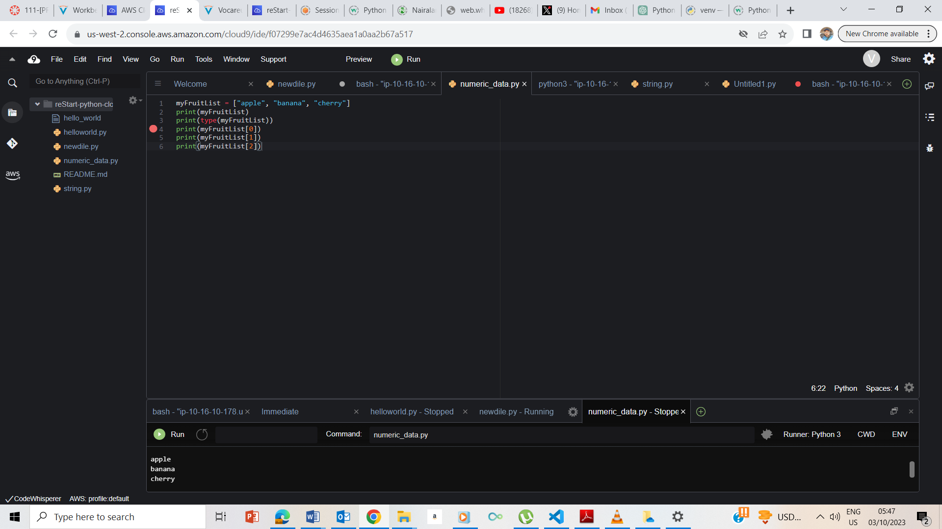

I used their various indexes to access the fruits

### **Changing the values in a list**

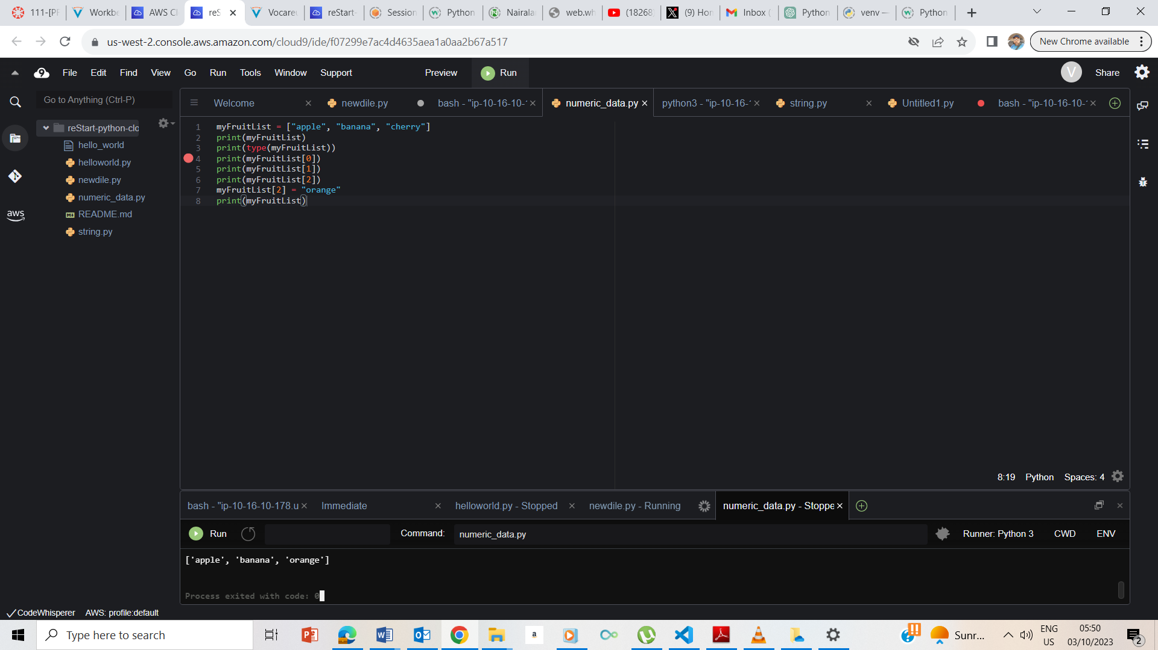

Changed the item in a list using their index and printed out the updated list.

## **Exercise 2: Introducing the tuple data type**

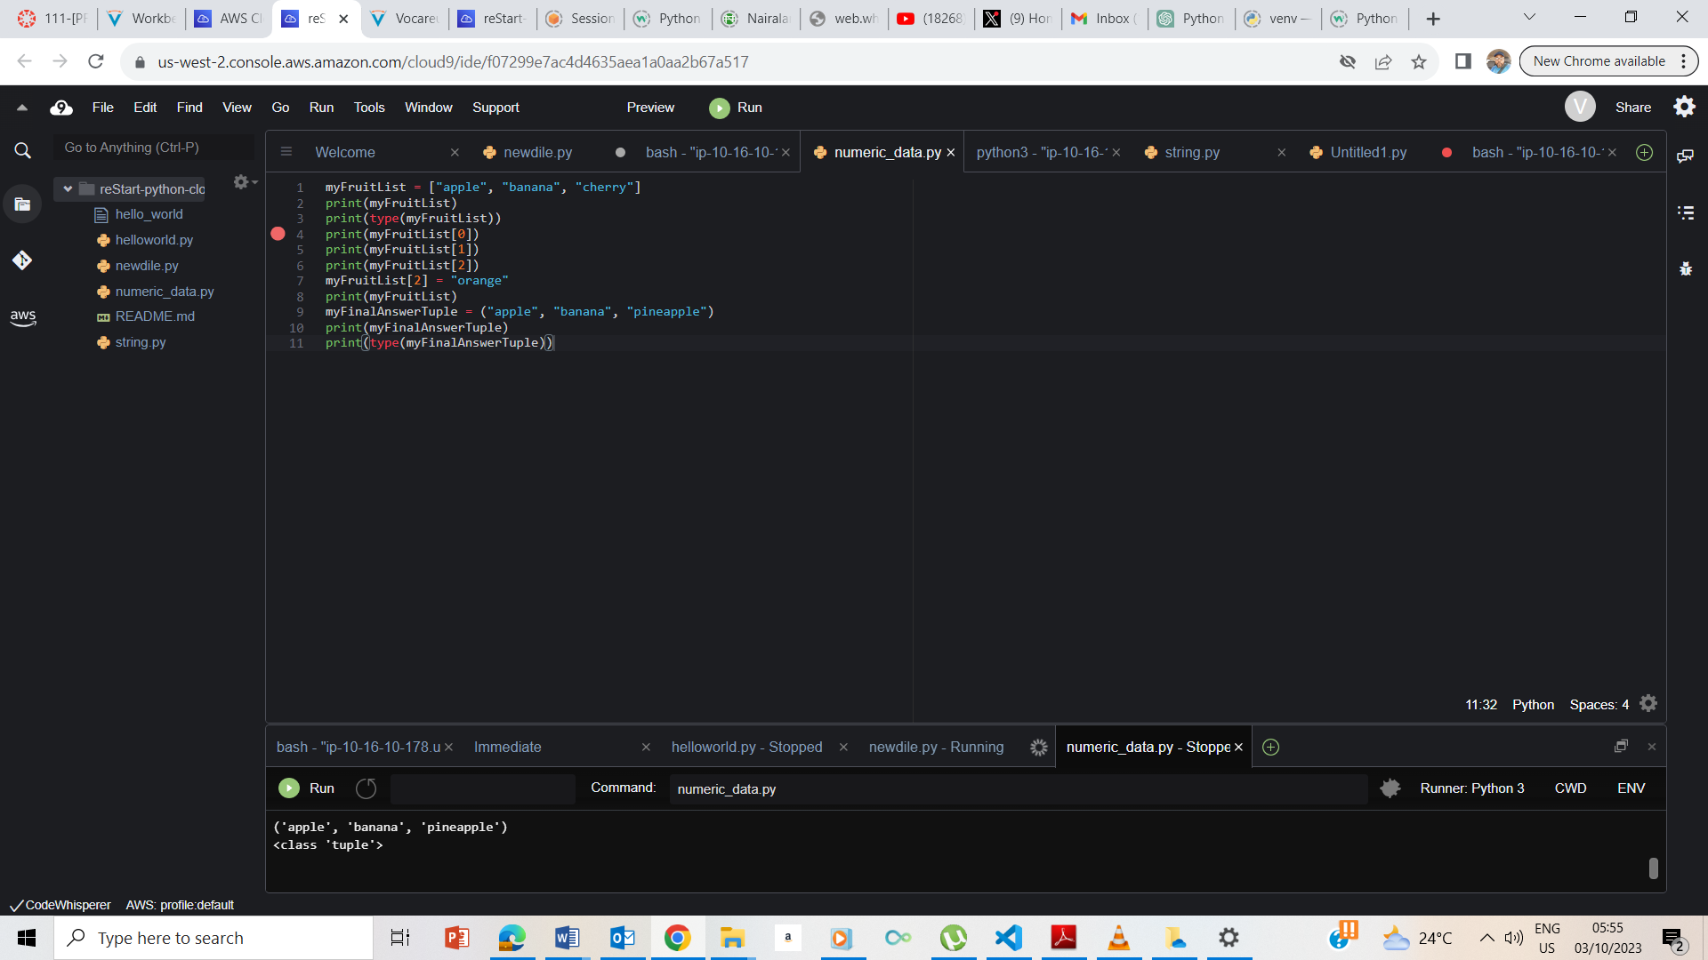

I entered the codes as instructed and the script ran as expected.

### **Accessing a tuple by position**

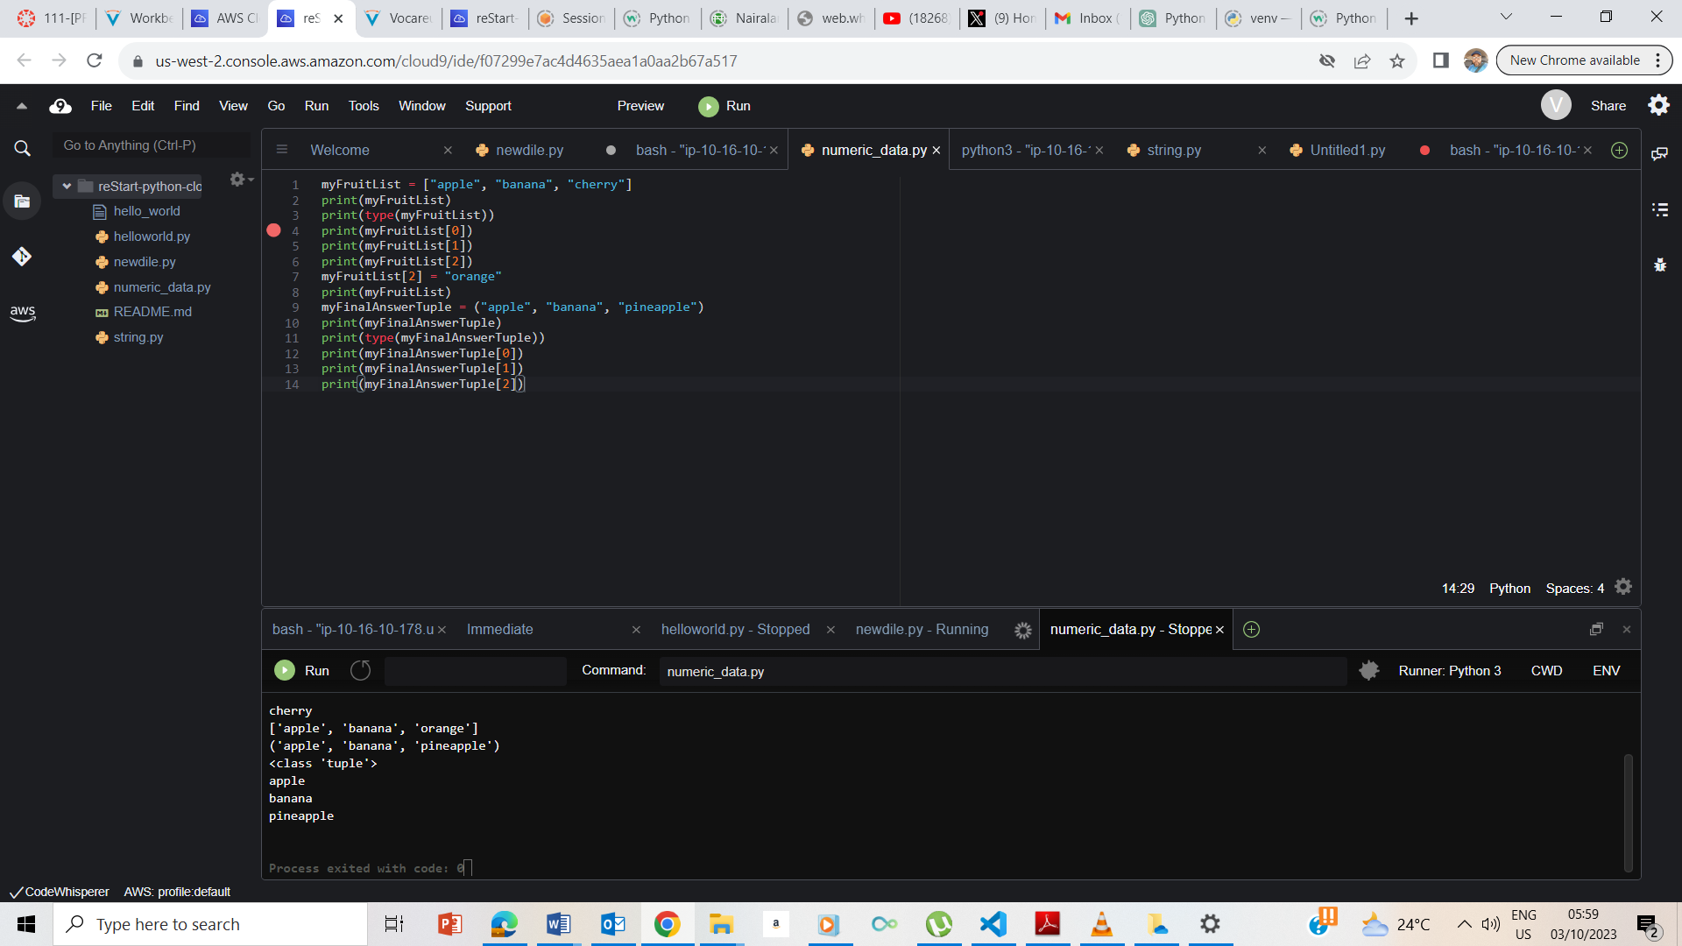

I followed the instruction and the code ran as expected.

## **Exercise 3: Introducing the dictionary data type**

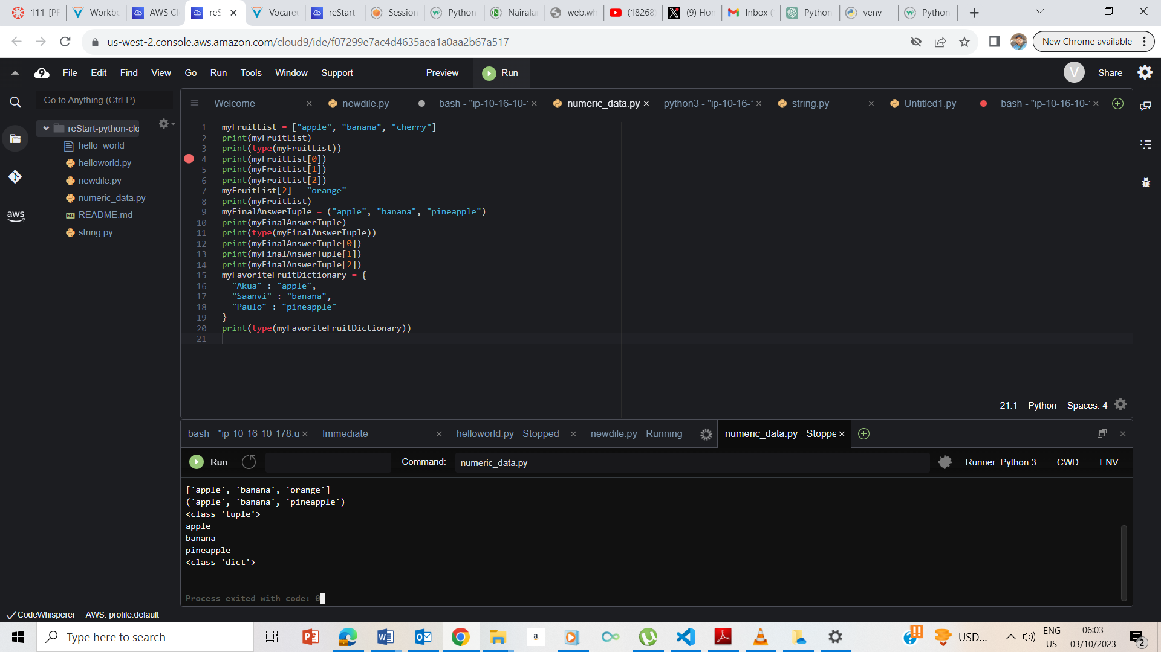

I entered the code as instructed and it ran as expected with output of class Dict

### **Accessing a dictionary by name**

By accessing the dictionary through their keys, the fruit names were printed out.

## **End Lab**

